**Introduction**

to the presentation of experimental results and all the results refer to simulations. The basic requirement is the MATLAB software .The MATLAB helps to simulate the result. MATLAB (matrix laboratory) is a numerical computing environment and fourth-generation programming language. MATLAB allows matrix manipulations, plotting of functions and data, implementation of algorithms, creation of user interfaces, and interfacing with programs written in other languages, including C, C++, Java, and FORTRAN. The life time of network basically depends on no. of alive nodes. If there is less number of alive nodes then life of network is ended.

The simulation parameters which are used to increase life time of network.

* Dead nodes
* Alive nodes
* Packet transmission rate

**Simulation Result**

Life time of network related to no. of alive nodes, no. of dead nodes, and rate of packet transmission and how long time cluster of nodes is formed in network. System which is proposed here gives good output in all three parameters.We have take all these values and found that there are less dead nodes and more alive nodes in the proposed system. Also, the rate of packet transmission is enhanced and due to more alive nodes, the cluster formation process is ensued for a long time which tends to increase the life time of the wireless sensor network.

Modified system output shows improvement in four areas.

* There is less number of dead nodes.
* Number of alive nodes is enhanced.
* Packet transmission to base station occurs frequently.
* Even in last round clustering process is going take place.
* N = 150 nodes randomly distributed in a 100m *100m field.
* base station is in the center of the sensing region
* ignore the effect caused by signal collision and interference in the wireless channel
* radio parameters used in our simulations are shown

n= 150(normal and advanced)

P= 0.1;

Eo= 0.5;

ETX= 50*0.000000001;

ERX= 50*0.000000001;

Efs= 10*0.000000000001;

Emp= 0.0013*0.000000000001;

EDA= 5*0.000000001;

EDA= 5*0.000000001;

rmax= 5000;

do= sqrt(Efs/Emp);

|  |  |  |
| --- | --- | --- |
| **Variable** | **Description** | **Initial Value** |
| **n** | Total number of sensor nodes | 150 |
| **p** | Probability factor | 0.1 |
| **Eo** | Threshold energy value | 0.5 |
| **rmax** | Maximum number of rounds | 5000 |
| **ETX** | Energy required to transmit | 50*0.000000001 |
| **ERX** | Energy required to receive transmission | 50*0.000000001 |
| **Efs** |  | 10*0.000000000001 |
| **Emp** |  | 0.0013*0.000000000001 |
| **EDA** | Entropy based Data Aggregation | 5*0.000000001 |
| **do** | Signal to Noise Ratio | sqrt(Efs/Emp) |

These are the basic parameter taken for simulation of results in WSN. Here n is number of nodes, p is the probability factor, Eo is the thresh hold energy value, rmax is the no. of maximum rounds.

In this scenario we are taking n= 150 i.e no. of nodes in network is 150. The probability factor p and thresh hold value Eo and number of rounds rmax will be taken constant

**Conclusion/proper result**

* LEACH fails to take full advantage of the extra energy provided by the heterogeneous nodes.
  + The stability period of LEACH is very short and nodes die at a steady rate. This is because LEACH treats all the nodes without discrimination.
* Our protocol takes initial energy and residual energy into account at the same time. The results show increase in more rounds of stability period than LEACH.
* Interestingly, though the number of nodes alive of Leach also differs and the packets delivered are more in our protocol. This means that our protocol is more efficient than LEACH.
* **From the analysis it is found that taking scenario i.e. LEACH V/S proposed protocol that leach protocol persist for nearby 1450(approx.) no of rounds or iteration whereas our protocol persist till 2400(approx.) rounds hence much better than the former**

**Future Scope**

Various directions in which further research work can be carried out are following:

1. We change the parameters on which election of the heterogeneous nodes network is carried out for example, as in some other protocol like ISEP a combination of average and residual energy is taken.
2. Also, we can extend the heterogeneity of nodes by having three levels like normal node, intermediate node and advanced for deployment in our multi-level energy transmission.
3. We can change direction of our study to GPS EQUIPPED sensor nodes which are capable of location based sensing and apply our concept to that specific domain.
4. Multi sinks can be taken for the same idea in case application area in which network is to be deployed is having such possibility.
5. Multi-hop concept between cluster head nodes away from sink can be paired with multiple transmission level and heterogeneous network.

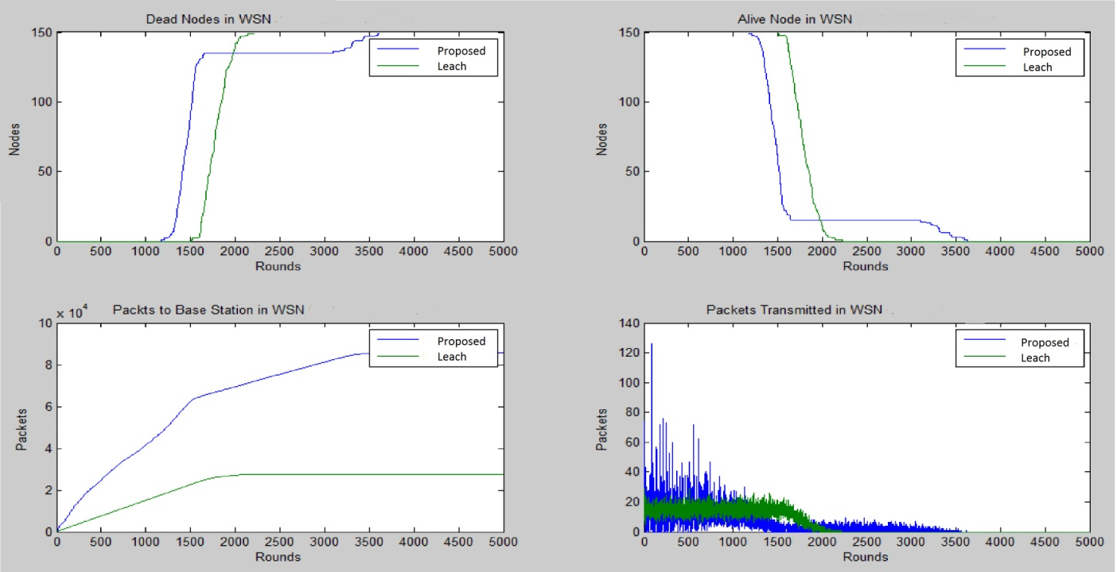

**From the analysis it is found that taking scenario i.e. LEACH V/S proposed protocol that leach protocol persist for nearby 1450(approx.) no of rounds or iteration whereas our protocol persist till 2400(approx.) rounds hence much better than the former**







**Topology**

Sensor nodes may be deployed randomly or in a structured manner. The network may have a uniform or non-uniform node density. Nodes in the network can be of the same type to form a homogeneous network, or have various capabilities to form a heterogeneous network. Topology control in homogeneous network with uniform structure is simple because of the a priori knowledge about the relative location and capability of other nodes in the network. Without this a priori knowledge, topology control is more challenging in post-deployment configurations and more complex protocols are needed to collaborate the work among nodes

**In our work, the deployment of nodes is done in 100 by 100 area**

Area1X=100;

Area1Y=100;

**base station is in the center of the sensing region**

Desination.x=0.5*Area1X;

Desination.y=0.5*Area1Y;

N = 150 nodes randomly distributed in a 100m *100m field using Rand()

**The sensor nodes of normal energy and advanced energy are distributed in sensor region near the base station in circular region having radius 4 in ratio of 3:1.**

**And rest of the nodes left are distributed in area outside the cicular region near the base station.**